Analysis of the logistical benefits of RFID in autonomous markets.
Análise dos benefícios do RFID em mercados e mercados autônomos
Análisis de los beneficios de la RFID en mercados y mercados autónomos

Hernandes Arthur Santos
hernandes.santos01@etec.sp.gov.br

Gustavo Rodrigues Da Silva¹
gustavo.silva2045@etec.sp.gov.br

Erick Ferreira Lima¹
erick.lima61@etec.sp.gov.br

Jeferson Roberto de Lima¹
jeferson.lima17@etec.sp.gov.br

Rogério Bezerra Costa¹
rogerio.costa3@etec.sp.gov.br
Keywords:  RFID.  Stockout.  Logistics.  Autonomous markets.  Palavras-chave:  RFID.  Ruptura de estoque.  Logística.  Mercados autônomos.  Palabras clave:  RFID.  Ruptura de stock.  Logística.  Mercados autónomos.  Presented on:  December, 03rd, 2025  Event:  8º EnGeTec  Event Local:  Fatec Zona Leste  Avaliadores:  Avaliador 1  Avaliador 2   | Abstract:  The present article seeks to understand how stockout occurs and how the implementation of technologies aimed at mitigating this issue becomes crucial in the logistics sector. The technology addressed here is Radio Frequency Identification (RFID). This technology was chosen because, preliminarily, the stockout problems identified are caused by a lack of product traceability. The research focuses on shelf-based products, aiming for better integration in autonomous markets. However, the topic is relevant to the entire logistics area, as there is a need for investment in new technologies to prevent stockout and other issues—improving not only customer comfort by avoiding unnecessary encounters with empty shelves or expired products but also increasing product reliability by turning the shelf into the final stage of the logistics chain.  The article investigates how RFID technology can reduce stockout by enhancing product traceability, promoting greater logistical efficiency, and contributing to a better consumer experience.  Resumo:  Este artigo analisa como as rupturas de estoque ocorrem e como a Identificação por Rádio Frequência (RFID) pode ajudar a evitá-las. O estudo foca em produtos de prateleira para melhorar a integração em mercados autônomos. As rupturas geralmente resultam de baixa rastreabilidade dos produtos, e o RFID oferece monitoramento em tempo real que aumenta a eficiência logística. Ao reduzir prateleiras vazias e produtos vencidos, essa tecnologia melhora a satisfação do cliente e a confiabilidade dos produtos, tornando a prateleira o passo final e inteligente na cadeia logística.  Resumen:  Este artículo analiza cómo ocurre la ruptura de stock y cómo la Identificación por Radiofrecuencia (RFID) puede prevenirla. El estudio se centra en productos de estanterías para mejorar la integración en mercados autónomos. Las rupturas suelen deberse a la falta de trazabilidad, y la RFID permite un seguimiento en tiempo real que aumenta la eficiencia logística. Al reducir estanterías vacías y productos vencidos, la tecnología mejora la satisfacción del cliente y la confiabilidad de los productos, convirtiendo la estantería en una etapa final inteligente de la cadena logística.
- Introduction
The present article seeks to understand how stockout occurs and how implementing technologies aimed at mitigating this issue becomes crucial in the logistics sector. The technology addressed here is Radio Frequency Identification (RFID).
Stockout refers to the situation in which an item should be on the shelves but is unavailable. This problem may arise from several factors, but the main one usually lies in the product’s traceability — or lack thereof — at some point along its distribution chain (VASCONCELLOS; SAMPAIO, 2009). Issues like this occur not only in autonomous markets, the primary focus of this article, but throughout the entire logistics sector.
The growing popularity of autonomous markets in Brazil has positioned the country as one of the leaders in this area. This increased popularity is attributed to the convenience and safety provided by this business model, functioning both as a source of income for the owner/franchisee and as a source of convenience for customers (LEÃO, 2024). However, it is essential to adopt new technologies so that this sector does not suffer from the problems caused by stockout. In autonomous markets, stockout due to a lack of restocking undermines convenience and speed, representing an immediate loss of sales (SALEZ, [n.d.]).
Radio frequency technology has been used in the retail sector, promoting increased efficiency along with improved product traceability. A study published by the University of Arkansas reported a 13% increase in inventory accuracy after implementing RFID technology in test stores (HARDGRAVE, 2008). Looking at the Brazilian scenario, Renner stores — which now have 100% of their units using this technology — reported a 64% improvement in stock accuracy, speeding up restocking processes and preventing stockout (INFORCHANNEL, 2022).
Implementations of technologies such as radio frequency identification bring not only reductions in stockout but also increase visibility of product cycles for the end consumer; they also support regulatory compliance and enable the collection of product-movement data, promoting greater integration with Internet of Things (IoT) systems (BUDIYANTO; MUSLIM, 2024). Considering the losses caused by poor product traceability, how can the integration of RFID technology with IoT systems mitigate stockout and optimize product replenishment in autonomous markets?
- Theoretical Foundation
  - Automation in inventory control
In Brazil, the retail sector faces inventory management problems that result in financial losses for companies and a decline in consumer experience quality, with R$34.9 billion in losses recorded in 2024 (KPMG, 2024). According to Wenceslau (2024), these issues may stem from inaccuracies in human-driven processes or from malfunctioning software. To address this problem, the proposal detailed in this article aims to increase product traceability, reducing the dependence on human accuracy and delegating the auditing of items in autonomous markets to a system that uses RFID.
  - Internet of Things (IoT)
The product we developed, nicknamed Estok, will interact with both the digital and physical environments, identifying and recording the interactions of products with the shelves of the autonomous market, and these interactions will result in data collection. This characteristic classifies the project as part of the Internet of Things (IoT), which, according to Magrani (2018), refers to devices that feature Internet connectivity and information sharing, enabling integration scenarios between devices and services.
This data collection is important not only for making information available to the manager. The entry and removal of products from the shelf generate a large volume of data that can be leveraged beyond the scope of the present proposal. The collection and analysis of large amounts of real-time data enable better decisions and innovations in various sectors, aligning with the concept known as Big Data (SESTINO et al., 2020).
  - Radio frequency identification
As previously mentioned, to collect information about the products placed on the shelf, we will use Radio Frequency Identification technology. According to the studies of Ferreira (2021), an RFID tag contains an antenna that stores a unique identification code, making each tag singular. This tag holds the necessary information for product identification, enabling the entire process of accurately recognizing which product has been placed on the shelf (COSTA, 2018).
In our system, this antenna will be positioned near the shelf, identifying the interactions involving the entry and removal of RFID-tagged products, as shown in Figure 1.
Figure 1 – 3D model representing Estok on the shelf.
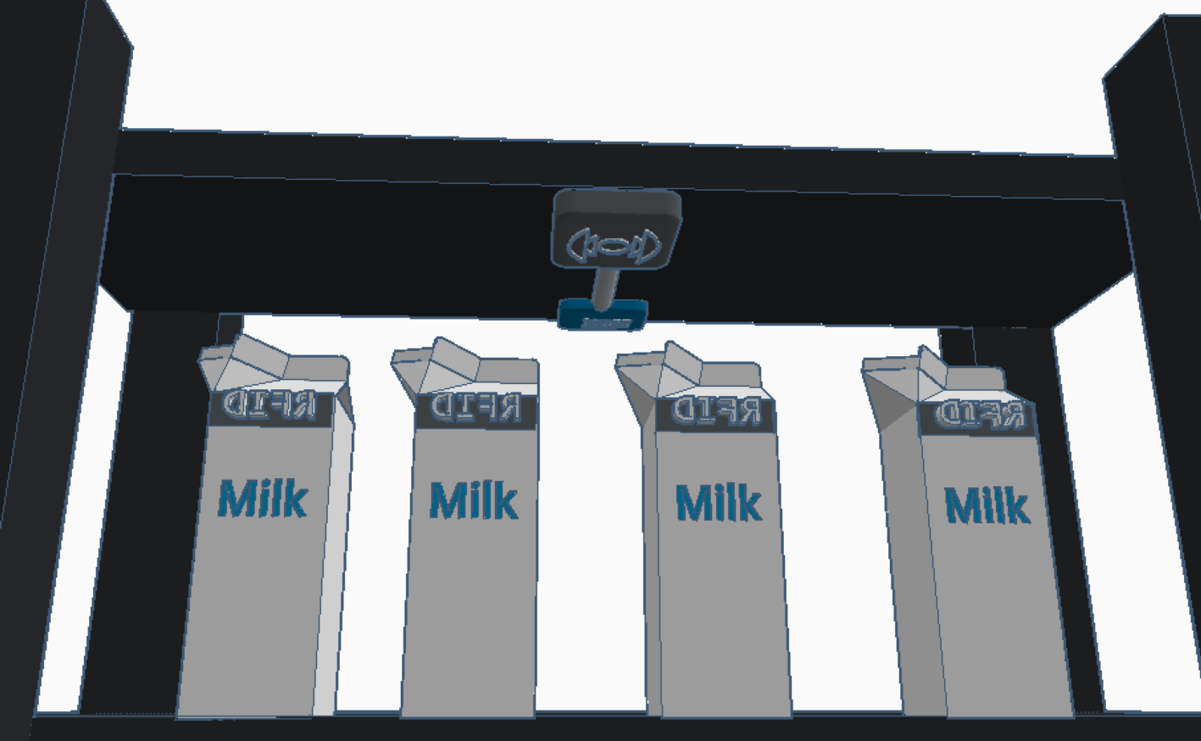
Source: Own authorship (2025)
Radio frequency identification technology was chosen due to its proven effectiveness in the Renner stores use case. In that implementation, stockout was reduced by 87% (SENSORMATIC, [n.d.]). Numbers like these highlight the importance of adopting technologies that increase inventory traceability, while also demonstrating the technology’s effectiveness. A graphical representation of radio frequency communication can be seen in Figure 2, where the antenna is shown on the right side of the image and the tag on the left.
Figure 2 – Graphic representation of radio frequency communication
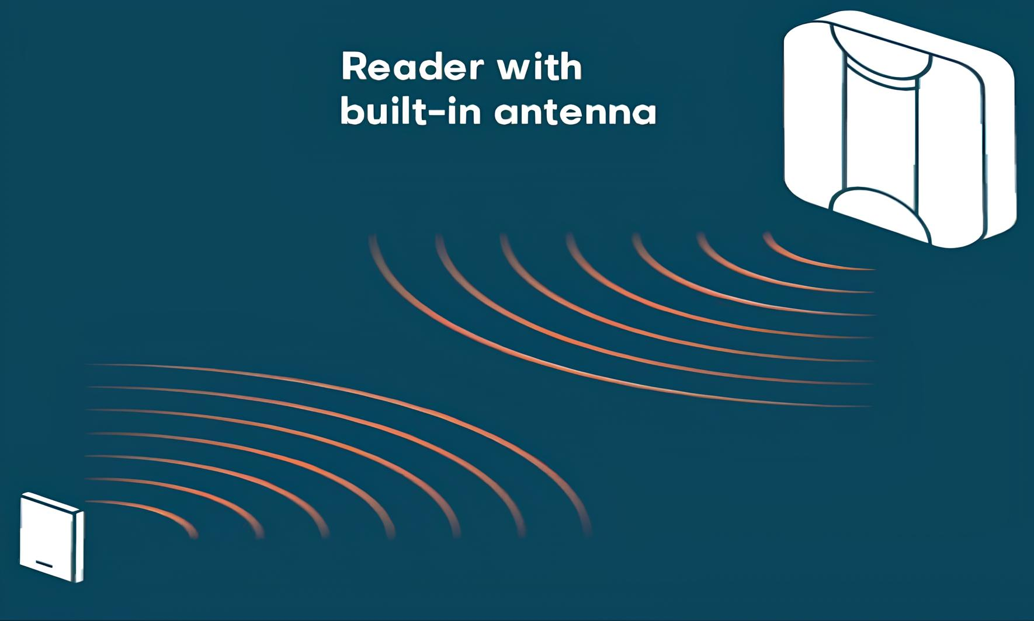
Source: Nedap ([s.d.])
  - Microcontroller
After the RFID reader captures the information from the tag, it must communicate this data to a microcontroller so that it can be processed and sent to the interface viewed by the autonomous market manager. The chosen microcontroller was the ESP32-WROOM-32, which plays a central role in physical control and IoT connectivity. Its selection is due to its Wi-Fi capability, which enables wireless communication, in addition to its low energy consumption, making it ideal for embedded applications and smart devices (ESPRESSIF, 2025). Figure 3 shows the ESP32-WROOM-32 microcontroller model that will be used in the construction of our prototype.
Figure 3 – ESP32 microcontroller board
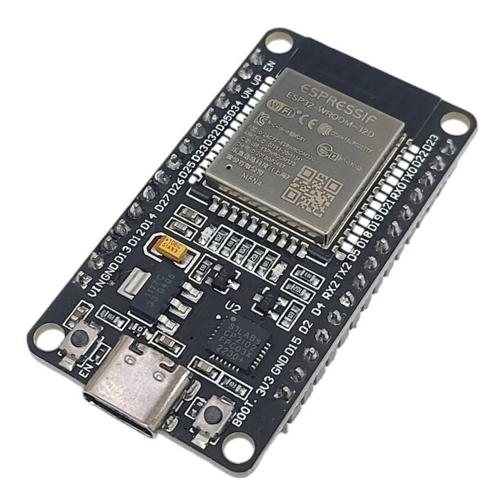
Source: Mamute Eletrônica ([s.d.])
  - Embedded programming
The microcontroller’s operating instructions will be provided through the C++ programming language. Its selection is due to its strong ability to control hardware resources (Microsoft, [n.d.]). As Wiener and Pinson (1991) state, C++ is an extremely effective programming language when aiming for more human-oriented solutions that make code easier to understand.
To define how the initial processing of the data read by the RFID reader should be handled by the ESP32 microcontroller, we will use an Integrated Development Environment (IDE). According to Carvalho (2023), the ESP32 is compatible with the Arduino IDE, an environment primarily used for boards from the Arduino family but also compatible with the ESP32. This IDE is supported both by the community and by the microcontroller’s manufacturer, making it an ideal choice due to its reliability (ESPRESSIF, 2025).
  - Graphical Interface
The information processed by the microcontroller will be made available to the autonomous market manager, and the framework chosen to perform this function was React, due to its focus on scalability (the ability of a site or system to grow according to new demands) and its component-based code structure. With its primary role in the frontend (the visual and interactive layer), React delivers its pages dynamically; as the user interacts with the page, new components are loaded. Websites with this characteristic are known as Single Page Applications (SPA) (OLIVEIRA, 2017).
React uses a type of file capable of mixing JavaScript with HyperText Markup Language (HTML), and this feature is what makes the framework so practical for building websites (WIERUCH; ROMERO, 2018). According to Lepsen (2018), JavaScript is the tool responsible for interactivity in web applications. HTML, in turn, is the technology used to create the structure of websites, enabling dynamic navigation through hypertext, which consists of links connecting pages to each other, as well as offering display elements such as text, images, and videos (DUCKETT, 2016). Figure 4 shows a component of the Estok dashboard.
Figure 4 – Product component requiring replacement

Source: Own authorship (2025)
  - Execution environment
To process the information coming from the physical device, we will use the JavaScript programming language mentioned earlier. Its use will be enabled by the Node.js development environment, a technology that allows data to be processed on the server side (KUMAWAT; SHRIVASTAVA; PANDEY, 2024).
According to Pereira (2014), Node.js—created in 2009 by Ryan Dahl with the initial help of 14 collaborators—stands out especially in applications that involve a high volume of data input and output (I/O). In this scenario, it is able to take full advantage of the server’s processing power efficiently, without interrupting the application while data is being processed, as occurred in other environments.
In the context of the current project, Node.js is necessary due to the high flow of data received by the IoT device. Its ability to avoid blocking the application while processing data is essential for our system.
- Methodology
The present research was developed using a quantitative approach that combined bibliographic and experimental methods, focusing on integrating theory and practice.
We first conducted a bibliographic study on inventory management, commercial automation, the Internet of Things (IoT), and RFID technology to consolidate the fundamental concepts of traceability and inventory control, aiming to demonstrate the importance of technological innovation in the retail sector and in autonomous markets.
Next, using data from companies and institutions that have implemented RFID systems—such as Renner stores and studies conducted by the University of Arkansas—we carried out an analysis to obtain a practical view of RFID performance in real contexts.
Complementing the previous steps, we conducted an experimental study with the Estok prototype, integrating hardware and software components. In this stage, we developed a system for reading and recording RFID-tagged products, programmed the ESP32 microcontroller in C++ to process the collected information, and implemented a visual interface developed in React for real-time visualization of the data processed in the Node.js environment, ensuring operational performance.
The quantitative methodology, which combined bibliographic and experimental approaches, allowed us to build a consistent analysis of the impact of RFID in autonomous markets. The combination of these methods enabled cohesive integration between theory and practice, resulting in a study that enhances the understanding of the benefits and challenges of the technology in inventory control. Thus, the methodology not only provided solid theoretical support for the topic but also demonstrated the efficiency of applying RFID technology, showing its potential to significantly mitigate stockout and optimize logistics management . The results emphasized how this create a more reliable and data-driven operational structure, reinforcing the value of RFID as a transformative tool capable of elevating accuracy, reducing operational failures, and improving the overall responsiveness of modern retail systems.
- Results and analysis
The research aimed to analyze the benefits of RFID technology in preventing stockout in traditional and autonomous markets, seeking to determine whether its implementation could improve traceability and logistical efficiency. The results confirmed this hypothesis: the use of RFID, integrated with the Estok prototype, proved capable of accurately recording product flow—a key factor in reducing control failures—thus enabling optimization of the restocking process.
- Final Considerations
The research reinforces that investing in automation and tracking technologies is essential for the advancement of the retail sector, directly impacting autonomous market models. The study also highlights the social contribution of the solution by enabling the reduction of stockout, improving the consumer experience, and preventing product waste.
As potential improvements, the expansion of system testing in real operating environments is proposed, along with integration into real-time data analysis platforms focused on predicting product demand. In this way, the research opens a path for future innovations through the use of Big Data generated by monitoring, enabling the use of this data to predict consumption and making retail—especially autonomous markets—far more automated and intelligent.
References
BUDIYANTO, Albert; MUSLIM, Muhammad. Optimizing Inventory Systems with RFID: A Narrative Review of Integration, Efficiency, and Barriers. [S.l]: Sinergi International Journal of Logistics, 2024. Disponível em: https://journal.sinergi.or.id/index.php/ijl/article/view/621. Acesso em: 06 nov. 2025.CARVALHO, Rafael et al. IOT PARA CONTROLE E GERENCIAMENTO RESIDENCIAL. Rio de janeiro: RevistaFT, 2023.
COSTA, Alexsander. RFControl: sistema de gerência de estoque utilizando RFID. Minas Gerais: Universidade Federal de Ouro Preto, Instituto de Ciências Exatas e Aplicadas, 2018.
DUCKETT, Jon. HTML & CSS: projete e construa websites. Rio de Janeiro: Alta Books, 2016.
ESPRESSIF. ESP32 Series. Xangai: Espressif Systems, 2025. Disponível em: https://documentation.espressif.com/esp32_datasheet_en.pdf. Acesso em 9 nov. 2025.
ESPRESSIF. Welcome to ESP32 Arduino Core’s documentation. Xangai: Espressif Systems, 2025. Disponível em: https://docs.espressif.com/projects/arduino-esp32/en/latest/getting_started.html. Acesso em 9 nov. 2025.
FERREIRA, Juliana Borges. Desenvolvimento de etiquetas planares passivas UHF RFID em superfícies metálicas e não metálicas com a proposta de uma figura de mérito para avaliação. Porto Alegre: Universidade Federal do Rio Grande do Sul, 2021.
HARDGRAVE, Bill. RFID Improves Inventory Accuracy, University of Arkansas Study Finds. Arkansas: Universidade de Arkansas, 2008. Disponível em: https://news.uark.edu/articles/11238/rfid-improves-inventory-accuracy-university-of-arkansas-study-finds. Acesso em: 3 nov. 2025.
INFORCHANNEL. Lojas Renner conclui projeto de implementação de etiquetas RFID. [S.I.]: InforChannel, 2022. Disponível em: https://inforchannel.com.br/2022/06/30/lojas-renner-conclui-projeto-de-implementacao-de-etiquetas-rfid/. Acesso em: 11 ago. 2025.
JENKINS, Abby. 20 Inventory Management Challenges and Solutions for 2022 and Beyond. Austin. NetSuite Oracle: 2022. Disponível em: https://www.netsuite.com/portal/resource/articles/inventory-management/inventory-management-challenges.shtml. Acesso em: 9 nov. 2025.
KPMG. Pesquisa Abrappe de Perdas no Varejo Brasileiro 2024. [s.l.], 2024. Disponível em: https://kpmg.com/br/pt/home/insights/2024/11/pesquisa-abrappe-2024.html. Acesso em: 27 mai. 2025.
KUMAWAT, Muskan; SHRIVASTAVA, Vishal; PANDEY, Akhil; KUMAR, Santos. Node.Js Review: A Comprehensive Overview of the JavaScript Runtime Environment. Bhopal: International Journal of Research Publication and Reviews, 2024. Disponível em: https://ijrpr.com/uploads/V5ISSUE4/IJRPR24534.pdf. Acesso em: 9 nov. 2025.
LEÃO, Leonardo. Minimercados autônomos ganham força no Brasil. Belo Horizonte: Diário do Comércio, 2024. Disponível em: https://diariodocomercio.com.br/negocios/minimercados-autonomos-ganham-forca-no-brasil/. Acesso em: 24 mai. 2025.
LEPSEN, Edécio. Lógica de Programação e Algoritmos com JavaScript: UMA INTRODUÇÃO À PROGRAMAÇÃO DE COMPUTADORES COM EXEMPLOS E EXERCÍCIOS PARA INICIANTES. 1. ed. São Paulo: Novatec, 2018.
MAGRANI, Eduardo. A Internet Das Coisas. Rio de Janeiro: FGV Editora, 2018.
Mamute Eletônica. Módulo DOIT-ESP-Wroom-32 DEVKITC ESP32D Dual Core WiFi Bluetooth. São Paulo: Mamute Eletônica, 2025. Disponível em: https://www.mamuteeletronica.com.br/modulo-doit-esp-wroom-32-devkitc-esp32d-dual-core-wifi-bluetooth-com-usb-tipo-c-26199?srsltid=AfmBOooCmHW_BIzimJfTg4f5xSrj_DPyw-hLOadyWEiouIMrzKAtvPG6. Acesso em: 12 nov. 2025.
Microsoft. Welcome back to C++ - Modern C++. [S.l]: Microsoft Learn, [s.d.]. Disponível em: https://learn.microsoft.com/en-us/cpp/cpp/welcome-back-to-cpp-modern-cpp?view=msvc-170. Acesso em: 9 nov. 2025.
Nedap. RFID vehicle access control explained. Groenlo: Nedap, [s.d.]. Disponível em: www.nedapidentification.com/insights/rfid-vehicle-access-control-explained/. Acesso em: 12 nov. 2025
OLIVEIRA, Daniel. Uma proposta de arquitetura para Single-Page Applications. Recife: Universidade Federal de Pernambuco Centro de Informática, 2017.
PEREIRA, Caio. Node.js Aplicações web real-time com Node.js. [S.I.]: Casa do Código, 2014. Disponível em: https://www.kufunda.net/publicdocs/Node.js%20-%20Aplica%C3%A7%C3%B5es%20web%20real-time%20com%20Node.js%20(Caio%20Ribeiro%20Pereira).pdf. Acesso em: 9 nov. 2025.
SALEZ, Julia. Preventing Stockouts: The Impact of New Retail Technologies on In-Store Team Operations. Rueil-Malmaison: Timeskipper, [s.d.]. Disponível em: https://www.timeskipper.co/en/preventing-stockouts-the-impact-of-new-retail-technologies-on-in-store-team-operations/. Acesso em: 6 nov. 2025.
SENSORMATIC. Renner reduz 87% da ruptura de seus estoques com tecnologia RFID da Sensormatic Solutions. [S.l.]: Sensormatic, [s.d.]. Disponível em: https://www.sensormatic.com/pt_br/resources/cs/2022/renner. Acesso em: 20 ago. 2025.
SESTINO, Andrea; PRETE, Maria. PIPER Luigi; GUIDO Gianluigi. Internet of Things and Big Data as enablers for business digitalization strategies. [S.l]: ScienceDirect, 2020. Disponível em: https://www.sciencedirect.com/science/article/pii/S0166497220300456. Acesso em: 9 nov. 2025.
VASCONCELLOS, Luis; SAMPAIO, Mauro. The Stockouts Study: an Examination of the Extent and the Causes in the São Paulo Supermarket Sector. São Paulo: Brazilian Administration Review, 2009. Disponível em: https://www.scielo.br/j/bar/a/jtyrkGbncB949n5BvBPtJgd/?format=pdf&lang=en. Acesso em: 6 nov. 2025.
WENCESLAU, Fernando. Como a automação e a tecnologia preditiva estão mudando a gestão de estoque. Santa Cataria: Economia SC, 2024. Disponível em: https://economiasc.com/2024/07/25/como-a-automacao-e-a-tecnologia-preditiva-estao-mudando-a-gestao-de-estoque/. Acesso em: 25 mai. 2025.
WIENER, Richard; PINSON, Lewis J. Programação Orientada para Objeto e C++. São Paulo: Makron Books, 1991.
WIERUCH, Robin; ROMERO, Claudio. The Road to learn React (Português). [S.l]: Leanpub, 2018. E-Book.

The content presented in this work, including copyright for figures and data, as well as orthographic and formatting compliance, is the sole responsibility of the author(s).
The authors of this work declare that, during the preparation of the manuscript, the tools ChatGPT were used for translation, and Perplexity and Elicit were used for article research. After using these tools, the authors edited and reviewed the content as necessary and assume full responsibility for the publication’s content.

ETEC da Zona Leste

